**Project 3– Ticker with MAX7219**

Sketch simulates one segment of a scrolling display

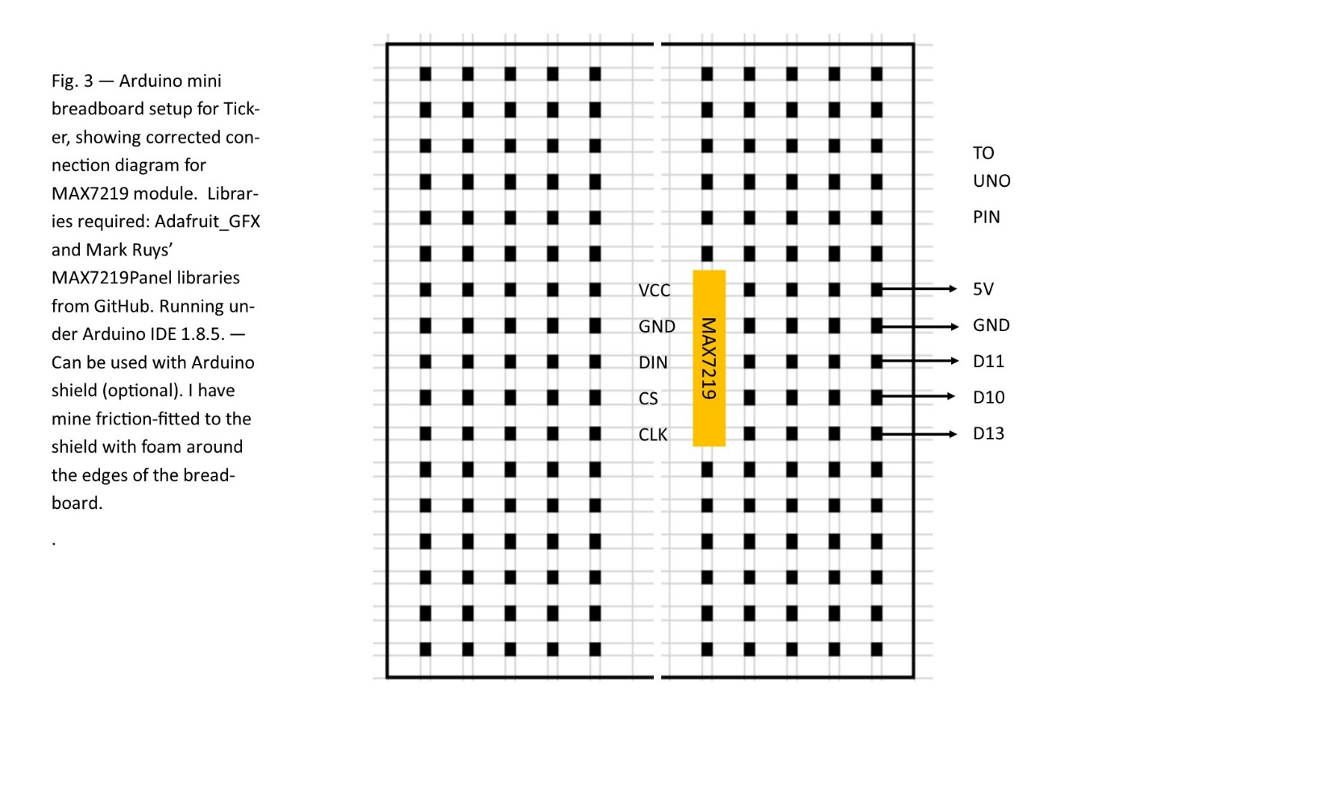

Code for Scrolling Display sketch

// Love Ticker by Bill Jenkins

// this sketch simulates a scrolling display on one 8x8 LED matrix

// The connections between the Arduino and the MAX7219 are:

// MAX7219 Arduino

// VCC 5V

// GND GND

// DIN D11

// CS D10

// CLK D13

#include <SPI.h>

#include <Adafruit_GFX.h>

#include <Max72xxPanel.h>

int pinCS = 10; // Attach CS to this pin, DIN to MOSI (11) and CLK to SCK (13)

int numberOfHorizontalDisplays = 1;

int numberOfVerticalDisplays = 1;

Max72xxPanel matrix = Max72xxPanel(pinCS, numberOfHorizontalDisplays, numberOfVerticalDisplays);

String tape = "BJ+VJ Productions - Arduino Scrolling Display - $99.95.... ";

int wait = 40; // In milliseconds

int spacer = 1;

int width = 5 + spacer; // The font width is 5 pixels

void setup() {

matrix.setIntensity(7); // Use a value between 0 and 15 for brightness

// Adjust to your own needs

// matrix.setPosition(0, 0, 0); // The first display is at <0, 0>

// matrix.setPosition(1, 1, 0); // The second display is at <1, 0>

// matrix.setPosition(2, 2, 0); // The third display is at <2, 0>

// matrix.setPosition(3, 3, 0); // And the last display is at <3, 0>

// ...

// matrix.setRotation(0, 2); // The first display is position upside down

// matrix.setRotation(3, 2); // The same hold for the last display

}

void loop() {

for ( int i = 0 ; i < width * tape.length() + matrix.width() - 1 - spacer; i++ ) {

matrix.fillScreen(LOW);

int letter = i / width;

int x = (matrix.width() - 1) - i % width;

int y = (matrix.height() - 8) / 2; // center the text vertically

while ( x + width - spacer >= 0 && letter >= 0 ) {

if ( letter < tape.length() ) {

matrix.drawChar(x, y, tape[letter], HIGH, LOW, 1);

}

letter--;

x -= width;

}

matrix.write(); // Send bitmap to display

delay(wait);

}

}